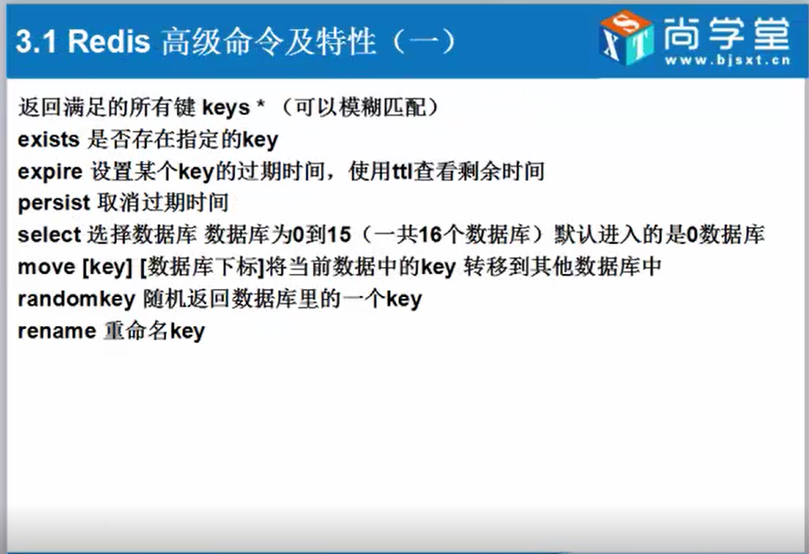

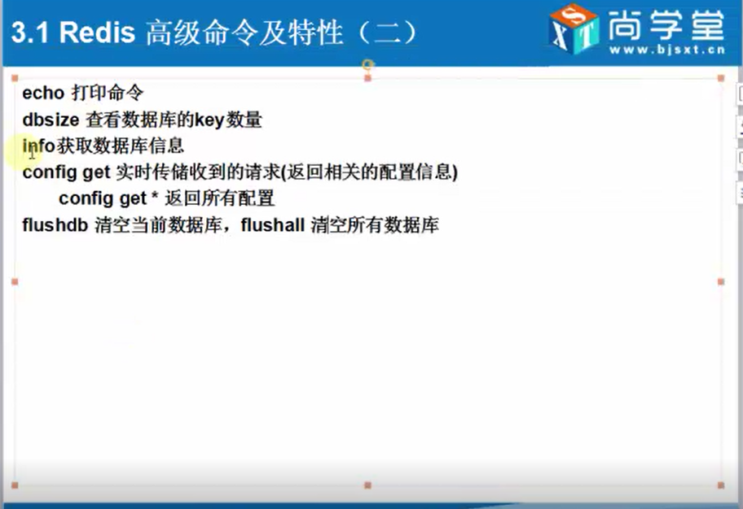

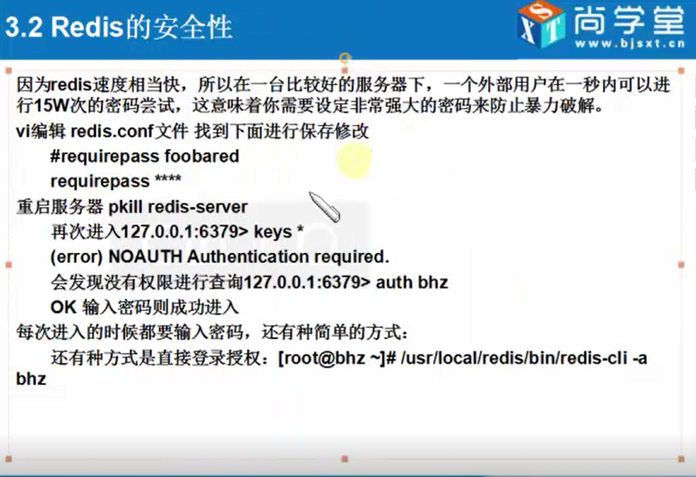

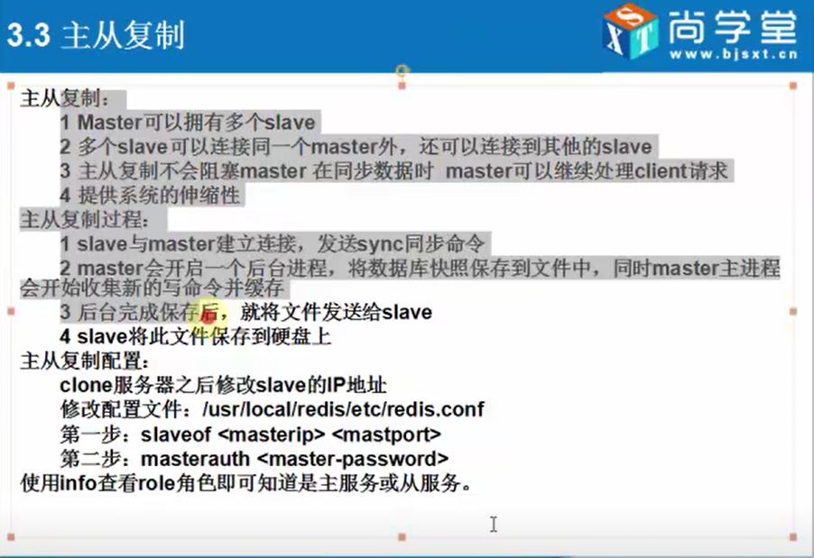

**>1. 在从服务器配置信息(189是主服务器)，从服务其是只读的**

# slaveof <masterip> <masterport>

slaveof 192.168.1.189 6379

**>2. 进入./redis-cli**

**>info**

# Replication

role:slave **(角色)**

master_host:192.168.1.189 **(主节点)**

master_port:6379

master_link_status:up

master_last_io_seconds_ago:1

master_sync_in_progress:0

slave_repl_offset:99

slave_priority:100

slave_read_only:1

connected_slaves:0

master_repl_offset:0

repl_backlog_active:0

repl_backlog_size:1048576

repl_backlog_first_byte_offset:0

repl_backlog_histlen:0

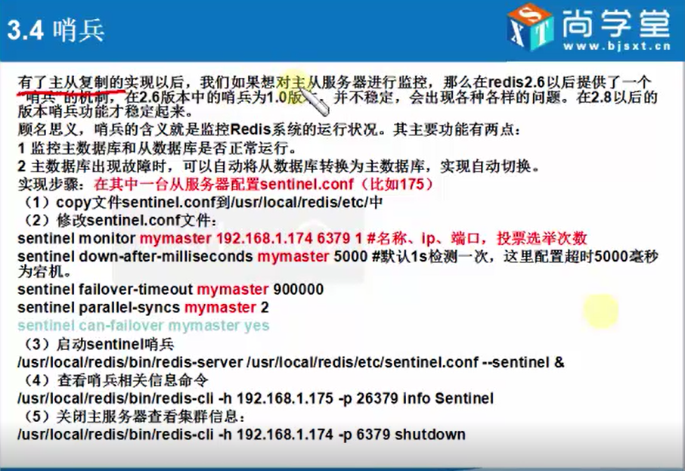

**>1. 修改配置文件**

**sentinel.conf**

dir /root/redis/dat **#哨兵服务相关的文件存放目录**

**# 1 : 有一台机器选举(一票),就切换为主节点**

sentinel monitor mymaster 192.168.1.189 6379 1

**#大概意思为从节点的数量，我们这里有两台从节点**

sentinel parallel-syncs mymaster 2

**>2. 启动哨兵(192.168.1.193) (&:表示后台启动)**

./redis-server ../sentinel.conf --sentinel &

**>3. 查看哨兵信息**

[root@Salve3 src]# ./redis-cli -h 192.168.1.193 -p 26379 info sentinel

# Sentinel

sentinel_masters:1

sentinel_tilt:0

sentinel_running_scripts:0

sentinel_scripts_queue_length:0

master0:name=mymaster,status=ok,address=192.168.1.189:6379,slaves=2,sentinels=1

**>4. 测试**

**关闭掉主节点，哨兵会重新选举新的主节点(哨兵节点打印如下信息)；**

**重新启动主节点，主节点变为从节点；**

2451:X 10 Jan 22:45:47.594 # +odown master mymaster 192.168.1.189 6379 #quorum 1/1

2451:X 10 Jan 22:45:47.594 # +new-epoch 1

2451:X 10 Jan 22:45:47.594 # +try-failover master mymaster 192.168.1.189 6379

2451:X 10 Jan 22:45:47.597 # +vote-for-leader 0f6b68fad8bad1bf251ae74f90abf61962ab83d7 1

2451:X 10 Jan 22:45:47.597 # +elected-leader master mymaster 192.168.1.189 6379

2451:X 10 Jan 22:45:47.597 # +failover-state-select-slave master mymaster 192.168.1.189 6379

2451:X 10 Jan 22:45:47.661 # +selected-slave slave 192.168.1.194:6379 192.168.1.194 6379 @ mymaster 192.168.1.189 6379

2451:X 10 Jan 22:45:47.661 * +failover-state-send-slaveof-noone slave 192.168.1.194:6379 192.168.1.194 6379 @ mymaster 192.168.1.189 6379

2451:X 10 Jan 22:45:47.762 * +failover-state-wait-promotion slave 192.168.1.194:6379 192.168.1.194 6379 @ mymaster 192.168.1.189 6379

2451:X 10 Jan 22:45:48.614 # +promoted-slave slave 192.168.1.194:6379 192.168.1.194 6379 @ mymaster 192.168.1.189 6379

2451:X 10 Jan 22:45:48.614 # +failover-state-reconf-slaves master mymaster 192.168.1.189 6379

2451:X 10 Jan 22:45:48.671 * +slave-reconf-sent slave 192.168.1.193:6379 192.168.1.193 6379 @ mymaster 192.168.1.189 6379

2451:X 10 Jan 22:45:49.670 * +slave-reconf-inprog slave 192.168.1.193:6379 192.168.1.193 6379 @ mymaster 192.168.1.189 6379

2451:X 10 Jan 22:45:49.670 * +slave-reconf-done slave 192.168.1.193:6379 192.168.1.193 6379 @ mymaster 192.168.1.189 6379

2451:X 10 Jan 22:45:49.723 # +failover-end master mymaster 192.168.1.189 6379

2451:X 10 Jan 22:45:49.723 # +switch-master mymaster 192.168.1.189 6379 192.168.1.194 6379

2451:X 10 Jan 22:45:49.723 * +slave slave 192.168.1.193:6379 192.168.1.193 6379 @ mymaster 192.168.1.194 6379

2451:X 10 Jan 22:45:49.728 * +slave slave 192.168.1.189:6379 192.168.1.189 6379 @ mymaster 192.168.1.194 6379

2451:X 10 Jan 22:46:19.745 # +sdown slave 192.168.1.189:6379 192.168.1.189 6379 @ mymaster 192.168.1.194 6379